Name: __________________________________________ Date: _________
Monotheism – Islam Mrs. Valdes

The Golden Age of Islam

The Arabs were influenced by the great civilizations of the ancient Middle East, as well as by the achievements of Greece and Rome. Arab rulers were known as caliphs. The capital of the caliphate moved first to Damascus in Syria and then to Baghdad in Iraq. During these centuries, while learning was in decline in Western Europe, a golden age flourished in the Islamic world. A golden age is a time of peace, prosperity, and great achievements. Arabs tolerated Christians and Jews, who contributed to Arab scholarship and culture.

Questions:

- Who influenced the Arabs? ________________________________________________________________________________________________________________________________________________________________________________________________________________________________________________________________________

- What did the Islamic world experience? ______________________________________________________________________________________________________________________________________________________________________________________________________

- Why did the Arabs’ tolerant policy towards Jews and Christians benefit the Arab world? ______________________________________________________________________________________________________________________________________________________________________________________________________

The Muslims built hospitals to care for the sick. In these hospitals, doctors studied why people got sick. Muslims became the first people to make a science of medicine. They studied it carefully and they trained their doctors carefully. From their study, they discovered that some sicknesses are contagious or can pass from one person to another.

One Arab doctor named Al-Razi wrote books about two diseases - smallpox and measles. Al-Razi may have been the first doctor to sew up cuts and to put casts on broken arms and legs.

Arab astronomers figured out that the earth is round. They correctly guessed that it was about 25,000 miles around. An Arab geographer was the first to put a map on a ball to show the right shape of the earth. Other Arab scientists studied light and were the first to learn that it travels in a straight line. They also learned that the curving of a lens makes things appear larger. The greatest Muslim scholar was an Arab named Jabir. His discoveries led to chemistry. Other Arab scientists invented much of the equipment we use today in chemistry.

Questions:

- How did Muslims develop the science of medicine? ______________________________________________________________________________________________________________________________________________________________________________________________________
- What were some of the Arab achievements in medicine? ______________________________________________________________________________________________________________________________________________________________________________________________________
- What was an Arab achievement in astronomy? ______________________________________________________________________________________________________________________________________________________________________________________________________

In mathematics, Muslim scholars expanded on what they learned from other people. From India, they borrowed the nine numbers that we still used today. We call these “Arabic numbers” even though they came from India. From the Hindus, the Arabs borrowed the decimal system and the idea of zero. Islamic artists never showed people or animals. They decorated mosques or Islamic houses of worship with beautiful designs and writing. Many Arab artists wrote poems about the beauty of nature and love. The best known Muslim poet was Omar Khayyam who wrote the Rubaiyat. Finally, Muslims rulers built beautiful palaces and mosques, richly decorated with mosaics, calligraphy, and geometrical designs.

Questions:

- Discuss Muslim achievements in mathematics. ______________________________________________________________________________________________________________________________________________________________________________________________________
- Describe Islamic art. ______________________________________________________________________________________________________________________________________________________________________________________________________
- Discuss the architectural achievements of Muslim rulers. ______________________________________________________________________________________________________________________________________________________________________________________________________

“Be happy for this moment. This moment is your life”
Omar Khayyam

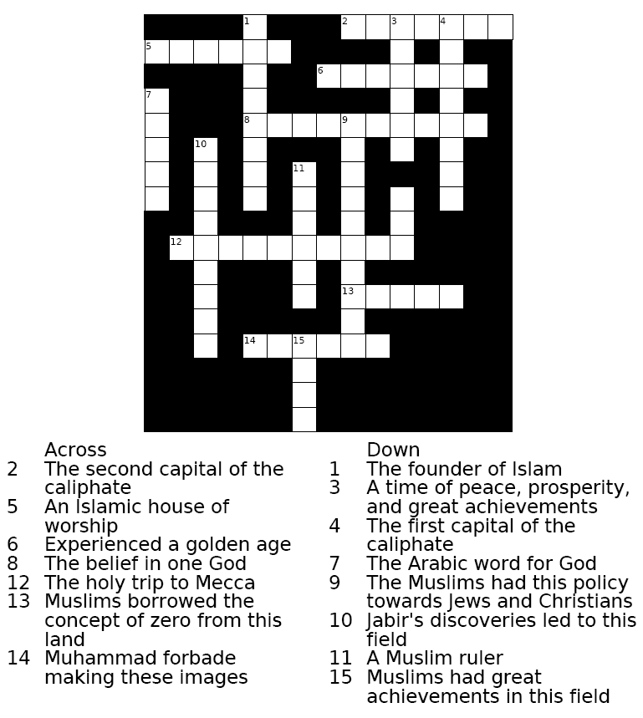

Word Bank:
Mosque | Muslims | Humans | Toleration | Damascus
Pilgrimage | Caliph | Math | Monotheism | Baghdad

Allah | Chemistry | Golden Age | Muhammad | India

- A major feature of the Golden Age of Moslem culture was the:

  - political and economic isolation of the Arab world
  - development of the foundations of modern science and mathematics
  - adoption of democratic government
  - persecution of Jews and Christians

- Which factor helps explain the scientific and literary achievements of the Muslims during their Golden Age (A.D. 800-1300)?

- expansion of trans-Atlantic trade
- innovations introduced by the Europeans during the Renaissance
- cultural diversity accepted by many Islamic governments
- legal equality of all people in the Islamic empire
- A major contribution of the Golden Age of Islam was the:
  - development of mercantilism
  - creation of the first polytheistic religion
  - spread of democratic ideals
  - advancement of mathematics and science

- The Golden Age of Muslim culture was best known for its:
  - attempts to colonize North America
  - frequent conflicts between Christians and Jews
  - advances in mathematics, science, and medicine
  - policies to reduce trade between the Middle East and China

“Most Gracious, Most Merciful."
"Master of the Day of Judgment."
"Thee do we worship, And Thine aid we seek."
Source: ’Abdullah Yusuf-Ali, trans., The Meaning of the Holy Qur’an, Amana Publications (excerpted)
5. This translated quotation from the Qur’an [Koran] refers to
a. Buddha c. Allah
b. Shiva d. Muhammad

- Christianity, Islam, and Judaism are similar in that they all ask their
followers to:
  - believe in reincarnation
  - strive for nirvana
  - follow a code of behavior
  - practice polytheism

